Comprehensive utilization of Aspergillus niger mycelium waste from citric acid fermentation on the basis of steam explosion and ionic liquid pretreatment
Qinyuan Ma^{1#}, Xiuzhen Gao^{2#}, Xinyu Bi¹, Menglei Xia¹, Qi Han³, Mingmeng Peng¹, Linna Tu¹,
Yupeng Yang¹, Yanbing Shen^{1*}, Min Wang^{1*}
¹ Key Laboratory of Industrial Fermentation Microbiology (Tianjin University of Science &Technology), Ministry of Education, Tianjin Key Lab of Industrial Microbiology, College of Biotechnology, Tianjin University of Science and Technology, Tianjin 300457, P. R. China
² School of Life Science, Shandong University of Technology, Zibo 255049, China
³ School of Science, College of Science, Engineering and Health, RMIT University, Melbourne, VIC, Australia

#These authors contributed equally to this work.
E-mail address: 18660686917@163.com (QY Ma); gaoxz@sdut.edu.cn (XZ Gao); 675281732@qq.com (XY Bi); mlxia@tust.edu.cn (ML Xia); cnhanqi@gmail.com (Q Han); 2326934860@qq.com (MM Peng); tulinna79@163.com (LL Tu); 251049672@qq.com (YP Yang); shenyb@tust.edu.cn (YB Shen); minw@tust.edu.cn (M. Wang).
*Corresponding authors; Tel.: 086 22 60600045; Fax: 086 22 60602298; E-mail: shenyb@tust.edu.cn; minw@tust.edu.cn.

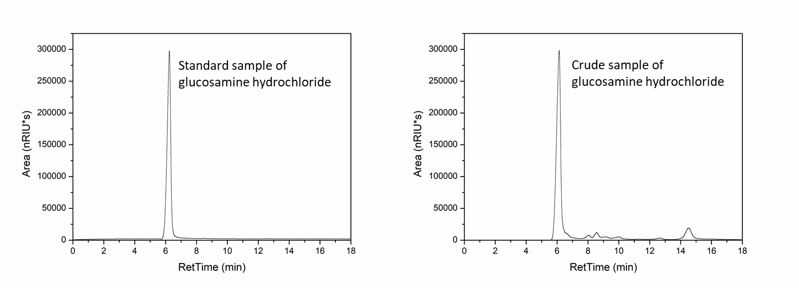
Supplementary data 1. HPLC results of standard and crude GlcN hydrochloride.

Supplementary data 2. XRD analysis of samples treated with CDA.

Supplementary data 3. FT-IR spectra of regenerated precipitate.

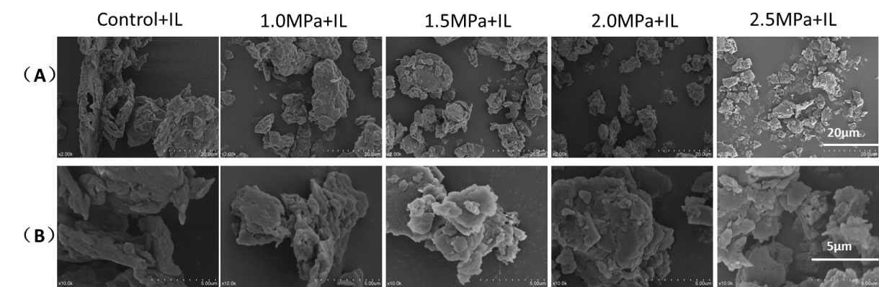
Supplementary data 4. SEM images(A&B) of combined pretreatment of SE and IL of fermentation residue.

Supplementary table 1. The main composition of the mycelium waste.
Component | Percent compositon  （%）
Dry matter | 88.5
Chitin (crude) | 3.9
Fiber (Crude) | 33.8
Hemicellulose(Crude) | 39.4
Protein (crude) | 7.9
Ash | 2.4
The data is the average production data for half a year of Weifang Ensign Industry Co., Ltd, China, which is the world's largest manufacturer of citric acid.

